Here are some steps to create an Administrator Account on AWS.
1. Login to the control panel
2. Click on the “IAM” tab on the control panel.
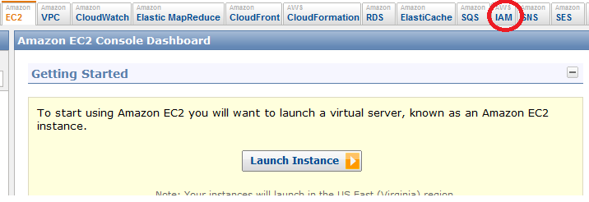
3. Click on “Groups”.
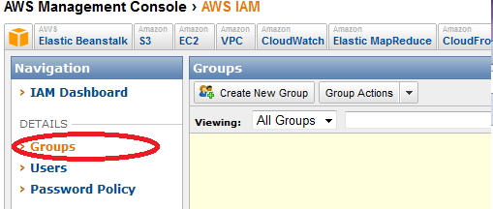
4. Click on “Create New Group”.
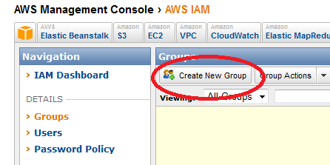
5. Give a Group name as “Administrator”. Note: This group has all permissions except billing information.

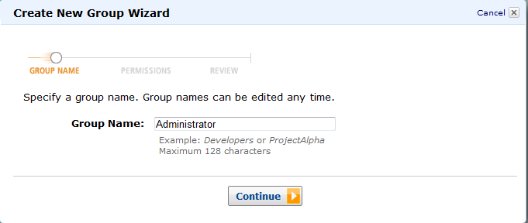
6. Then select “Administrator Access”
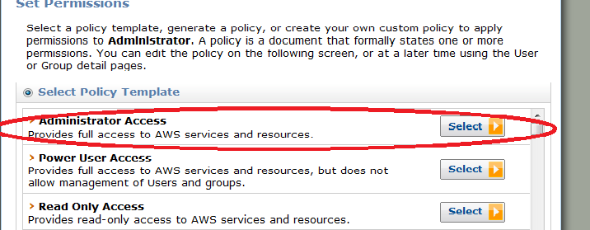
7. Then click on “continue” and then “Create Group”.
8. After that we need to create a user for the group.
9. Click on “Users” tab.
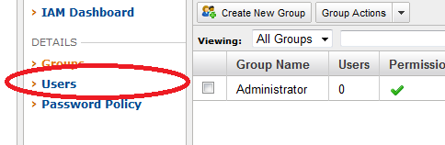
10. Click on “Create New Users”.
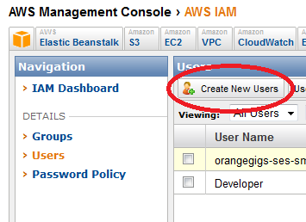
11. Give the name of the User.
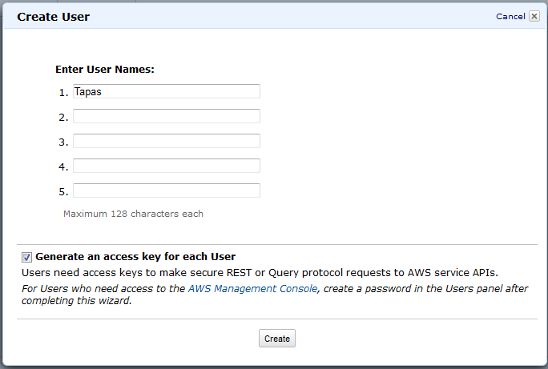
12. Then press “create”.
13. You have to download the security credential for the user. Click on “Download Credentials”.
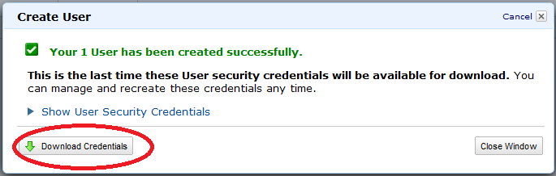
14. After completion of the download click on the “Close Window”.
15. Then we have to add the user to the Administrator group. For this
i. Click on check box of user Tapas.
ii. Click on “Add user” to Groups.
iii. Click on the check box of Administrator.
iv. Click on “Add to Groups”.
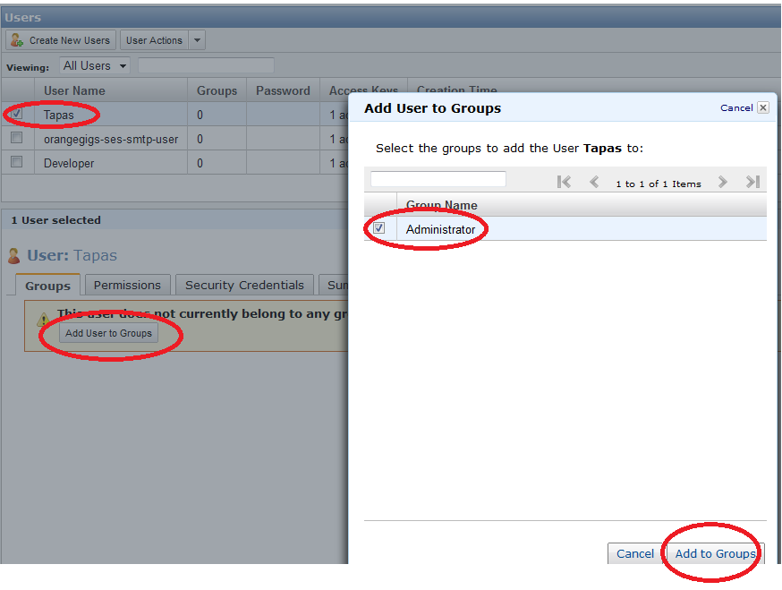
16. Then we have to set a password for the user. Click on “Security Credentials tab”.
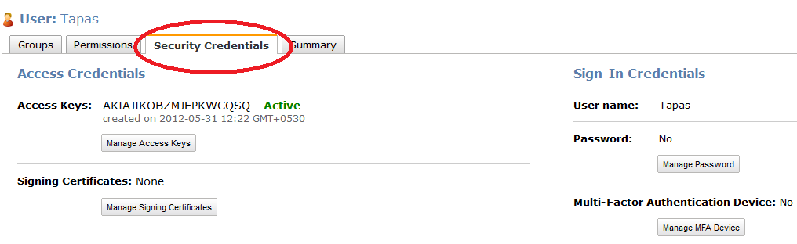
17. Click on Manage password. Then select “Assign a custom password”. Then give a password and press “Apply”.
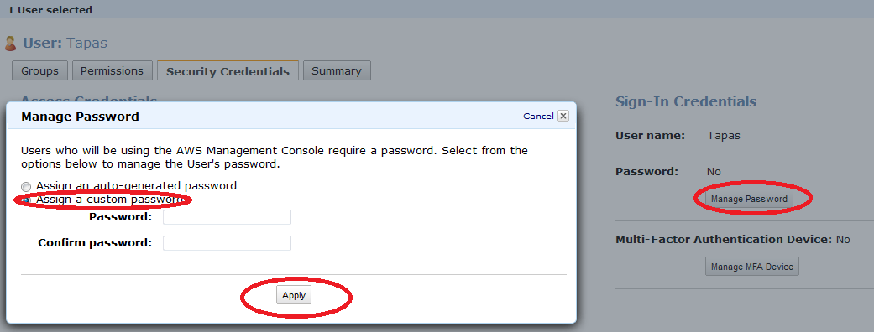
18. Then we have to create a custom URL by which user can login to the control panel. For this click on “IAM Dashboard”.
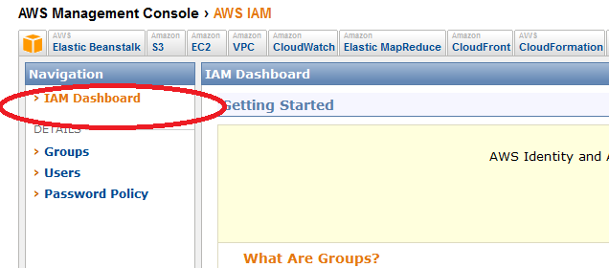
19. Click on “Create Account Alias”. Then give a name and press “Yes, Create”.
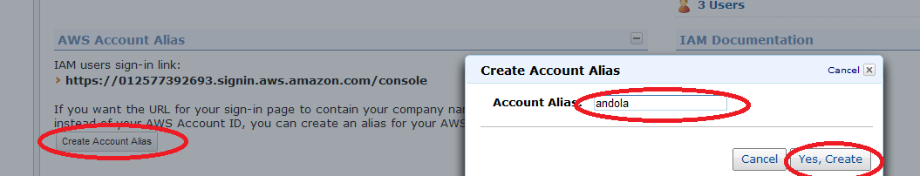
20. All things are finished finally you have to send the user below listed things to login his account.
a. User Name
b. Password
c. IAM users sign-in link
d. Users credential file which you downloaded from AWS.

